ICL7107 Voltmeter DIY Electronic Production Kit Manual

Measuring range: divided into 3 files, 0-2V file Measuring small voltage, 0-20V file measuring low voltage.
0-200V file measuring higher voltage.
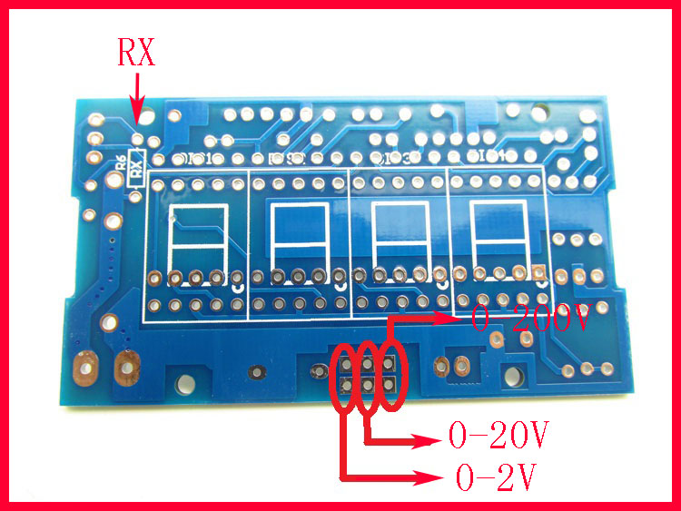
Range selection method: solder joints with file selection on the board,
When the two points of the 0-2V file are soldered together, and the resistance of the RX soldering resistor is 1K, the measurement range is 0-2V;
When soldering 2 points of 0-20V gear together, the RX soldering resistance is 100K, the measuring range is 0-20V;
When soldering 2 points of 0-200V file together, the RX welding resistance is 1M, the measurement range is 0-200V;
Overrange display: first position shows 1 or -1
In the kit, the RX is available in 100K and 1M, and the buyer selects the soldering according to his measurement range. This voltmeter can also be changed into an ammeter. The method of changing the current meter: reserve a 2W 0.1 ohm high-precision resistance soldering position on the board, solder this resistance, and then RX does not need to be soldered. This is a 0-2A ammeter.

Production steps:
Please carefully read the following steps before soldering. Some components must be installed in order, otherwise it may lead to unsuccessful production!

- ) Solder 1N4148, 5.1V Zener diode, where 1N4148 and 5.1V are distinguished. 1N4148 is written on 4148. The 5.1V Zener diode is written on ST5V1
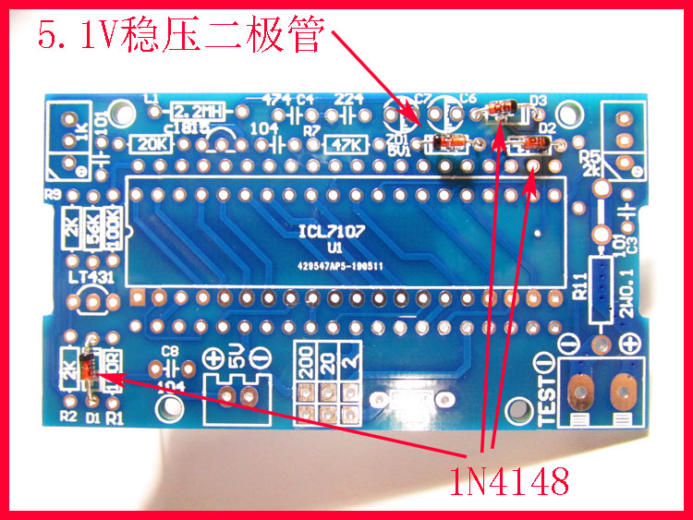

2.) Soldering resistors, resistance can be seen in the color ring or measured with a multimeter
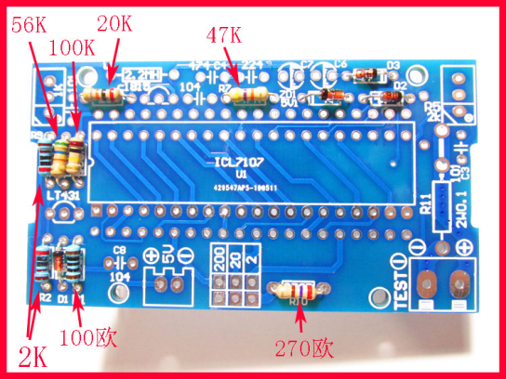

3.) Solder monolithic capacitors, electrolytic capacitors, adjustable resistors, C1815 triode and TL431.
The monolithic capacitor is soldered according to the parameters printed on the board, and has no polarity.
The 10UF electrolytic capacitor has a long positive pole and a short negative pole. The shaded portion of the PCB is printed with a negative electrode.
Adjustable resistance welding has a direction, pay attention to the above adjustment screw, refer to the following figure for welding.
C1815 and TL431 have the same appearance, and the lettering on the device is different. Pay attention to the distinction.
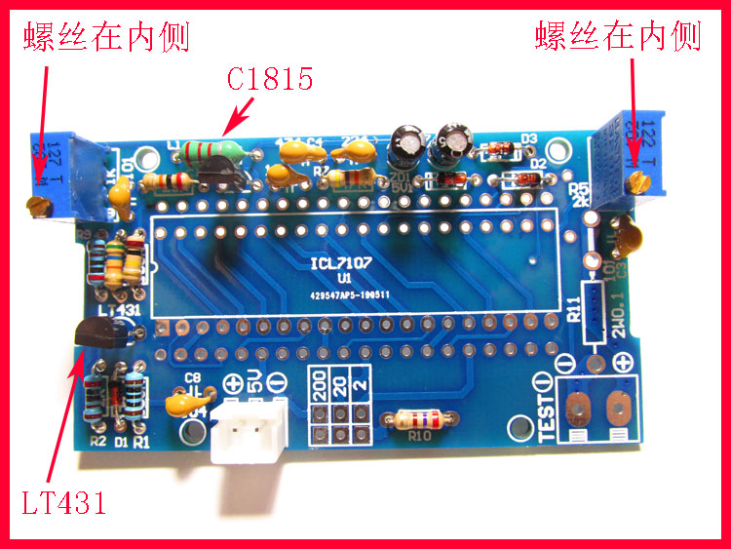
- ) Cut the IC holder into two rows of mothers with scissors, and then solder to the board.
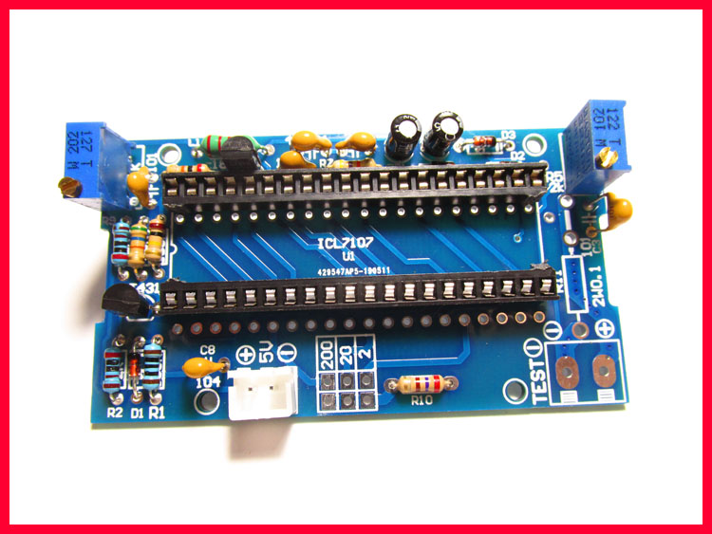
- ) Install 4 digital tubes (with direction), the decimal point of the digital tube corresponds to the decimal point of the silk screen on the board. The decimal point of the digital tube is close to the gear to select this side.
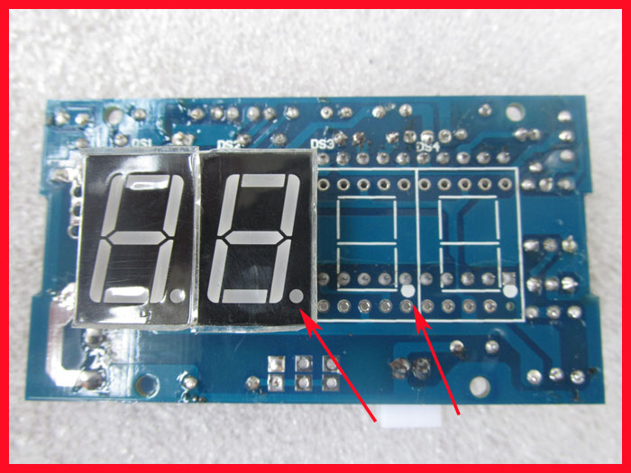
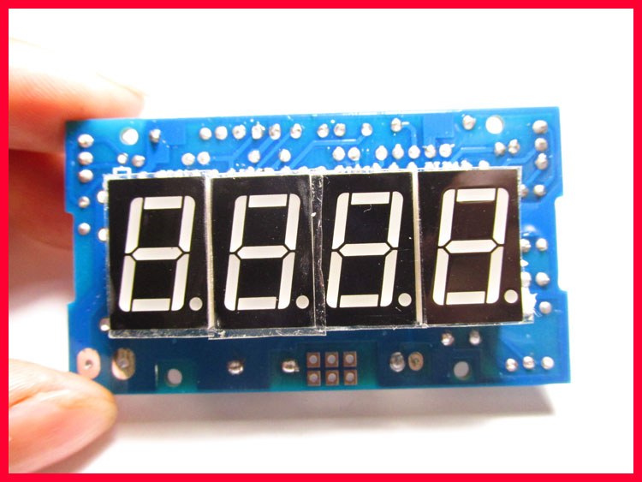

- ) After soldering 4 digital tubes, cut off the excess pins of the digital tube.
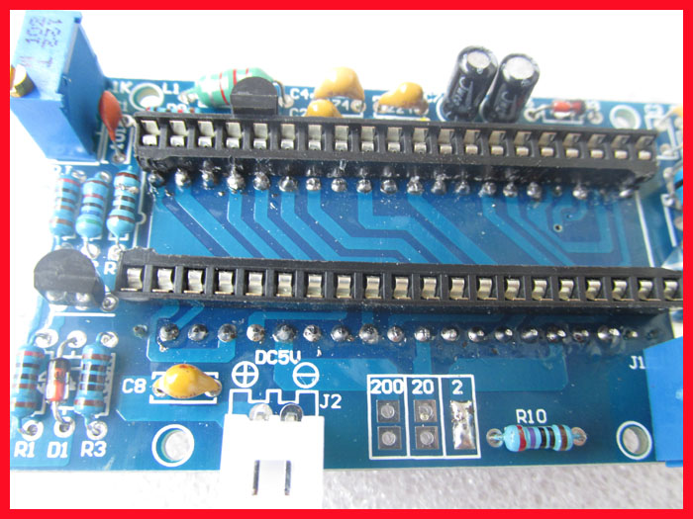
- ) Please insert the IC in the kit into the 40P IC holder (integrated circuit, pay attention to the direction).
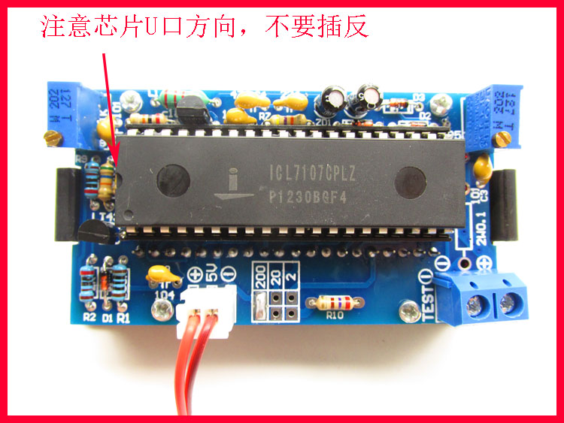
- ) Soldering gear selection and matching resistance.
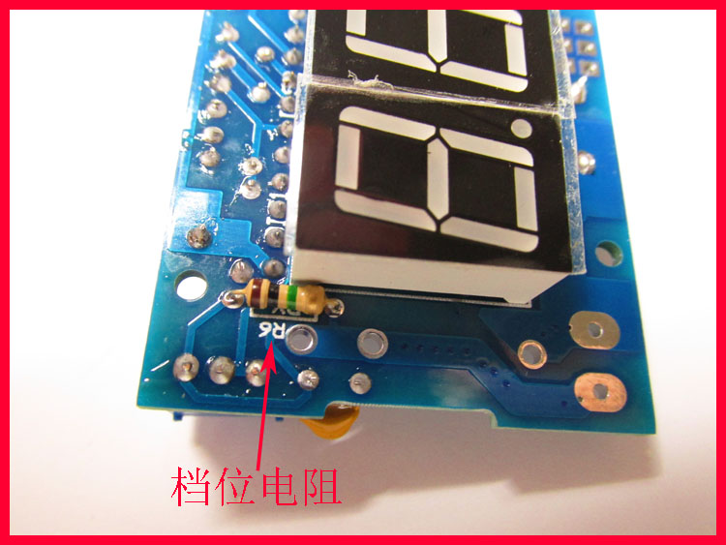
When the two points of the 0-2V file are solering together, and the resistance of the RX solering resistor is 1K, the measurement range is 0-2V;
When solering 2 points of 0-20V gear together, the RX solering resistance is 100K, the measuring range is 0-20V;
When solering 2 points of 0-200V file together, the RX solering resistance is 1M, the measurement range is 0-200V;

- ) Debugging method: power supply 5V (with direction, red to positive pole, black to negative pole, screen also has silk screen positive and negative), digital tube display -.000 or .000 is normal, adjust 3296-202 potentiometer, make chip number The voltage between the 36th and the 35th is 100MV.
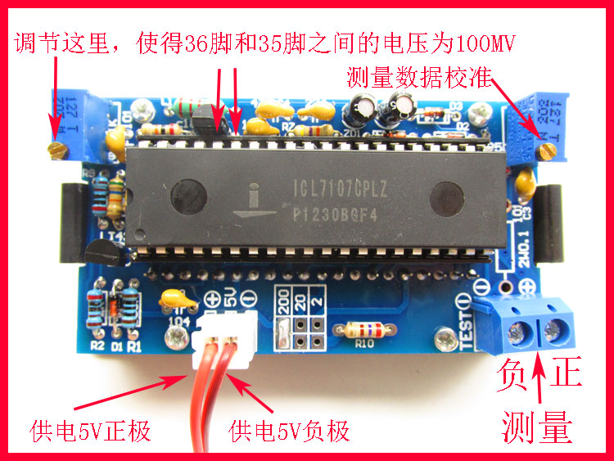

To measure the effect of the calibration potentiometer: input a voltage, then adjust the potentiometer. The value displayed on the meter is the same as the value measured by the multimeter.

