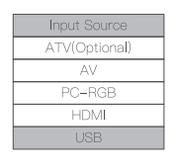--------->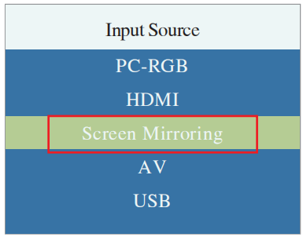
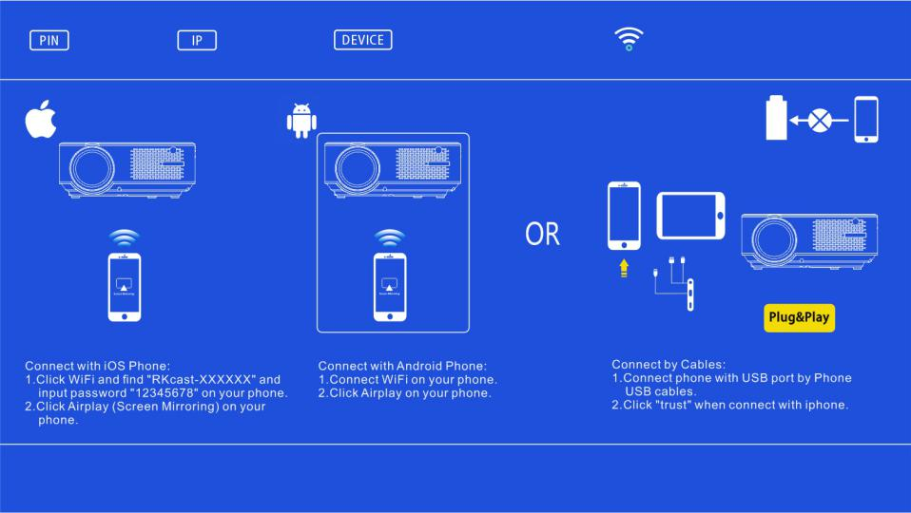
6.Screen Mirroring Connection
Press “Source” on the remote control or press “” on the control panel of the projector, select “Screen Mirroring” from “Input Source”, and press “OK” to enter. You can choose a wireless connection or a wired connection.
※Tips:
①The fluency of screen mirroring with wireless connection will be affected by the network environment.
②Make sure your mobile device is close to the projector when using a wireless connection. A distance within 1 meter is recommended.
③Some mobile devices may not support screen mirroring due to compatibility limitations.
④Long press "OK" for 10s to delete the screen mirroring configuration information, you can reconfigure.
Compatible systems
IOS | IOS 7 and above, iPhone 4+,iPad 2+, iPad4+
Android | Android 4.2 and above, has 1GB storage at least.
Wireless Projection Method
For IOS Devices
- Tap “Settings” and turn on Wi-Fi network. Choose the Wi-Fi name “RKcast-xxxxxx”, then connect to it and enter the password “12345678”, which is visible on the Projector’s menu.
※If you want to use Wi-Fi network, please perform the second step, otherwise skip this step.※
- Go to Safari, and enter “192.168.49.1”. And tap “Wi-Fi AP” ---> “Scan”, then select your Wi-Fi and enter the password, tap connect.
- Open the “Control Center” and click the ”Screen Mirroring” icon, find the device name “RKcast-xxxxxx”, click it to connect.
Note: After connecting, if “No Internet Connection” is displayed, please ignore it, as it will not affect operation of the device.
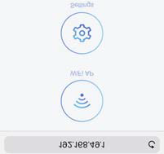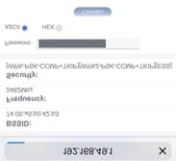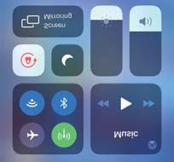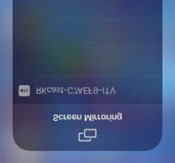
For Android Device
Tap “Settings” and turn on the Wi-Fi network.
※If you want to use a Wi-Fi network, please do the following:
1.Connect to your home Wi-Fi network and enter the password;
2.Tap “Settings”--->”Connection& Sharing” ---> “Cast”, turn on ”Cast” and connect “RKcast-xxxxxx”.
※If you want to use a mobile cellular network, please do the following:
1.Choose the Wi-Fi name “RKcast-xxxxxx”, connect to it and enter the password “12345678” which is on the projector’s menu.
2.Tap “Settings”--->”Connection& Sharing” ---> “Cast”, turn on ”Cast” and connect “RKcast-xxxxxx”.
Tips: Different brand mobile phones may have a different name for the Miracast function.
Wired Projection Method
For IOS Device
1.Connect the projector and IOS device with a USB cable;
2. "Do you trust this equipment?" is displayed, click "Trust".
For Android Device
1. Connect the projector and Android device with a USB cable;
2. Enter “Developer mode” and click “Developer options”, then open ”USB debugging”, a window will pop up "Allow USB debugging?" , tap "OK". After a while, the Android screen will be displayed on the projector.
Tips:
1.It is recommended to use the original USB cable to connect your device and the projector.
2.Some Android mobile devices may only transfer the display without audio due to protocol restrictions.

